SOUND
A. Sound
1. Is a form of energy produced and transmitted by vibrating matter.
2. Travels in longitudinal waves.
3. Travels more quickly through solids than liquids or gases – A medium (media pl.) is the matter though which waves travel.
B. Sound Waves
- ALL sound is carried through matter as sound waves.
- Sound waves are alternating areas of high and low pressure in the air.
- Sound waves move out in ALL directions from a vibrating object.
C. Sonar
1. An instrument that uses reflected sound waves to find underwater objects.
2. For example,
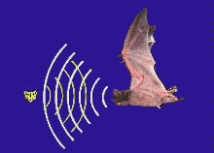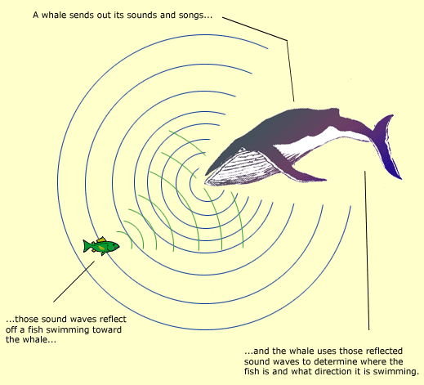
Animals use sonar or echolocation to find their prey; these sounds have such a high pitch or frequency that the human ear cannot hear them.
D. Interactions of Sound Waves
- Reflection
  - A reflected sound wave is called an echo.
  - The harder and smoother the surface, the stronger the reflection.

- Diffraction
- Sound waves can diffract, or bend, around corners and then spread out.
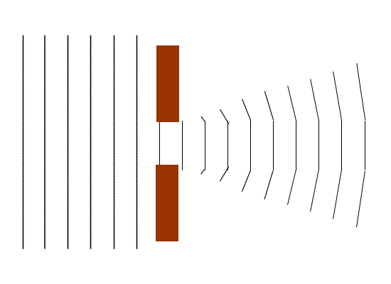
Interference
- When sound waves meet and interact with each other.
- It can be constructive or destructive.
Give ONE example of each type of interference
Constructive: louder sound
Destructive: silence
E. Measuring Waves
- Amplitude- volume of a wave (or height of a wave)
  - As wave height increases, volume increases
  - Measured in Decibels.
- Frequency- Pitch, high or low (length of a wave)
  - As wavelength increases, pitch decreases.
- Measured in Hertz.

F. Wavelength & Frequency
1. Wavelength is the distance between one part of a wave and the same part of the next wave.
2. Frequency is the number of waves moving past a point in one period.
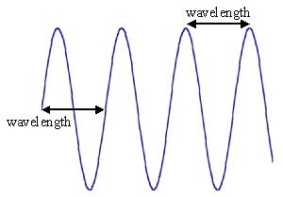

G. Volume
1. Is a measure of how loud or soft a sound is.
2. Volume depends on the amplitude of the sound wave.
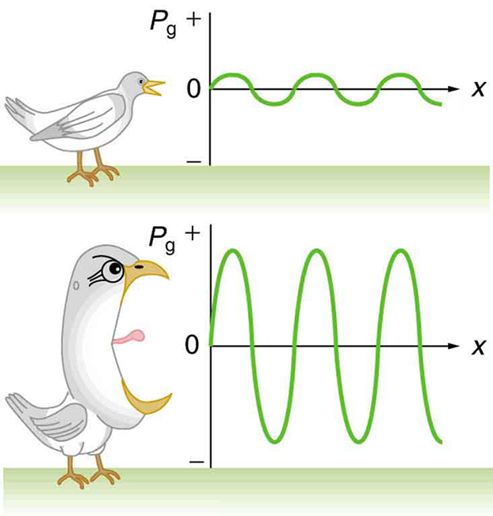

H. Pitch‎
1. Is a measure of how high or low a sound is.
2. Pitch depends on the frequency of a sound wave.
3. For example,
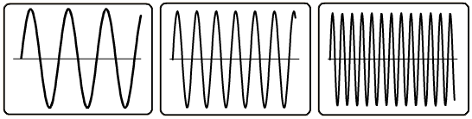
Low frequency High frequency
Low pitch High pitch
Longer wavelength Shorter wavelength

Amplitude versus Frequency
- Which one will have the higher volume?
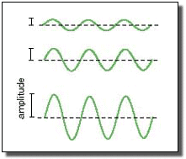
- Which one will have the higher pitch?
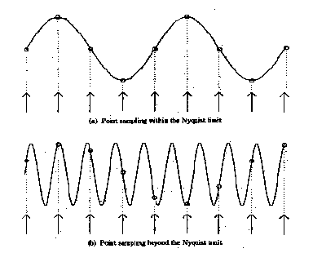
What can you hear?
Decibels (dB): Volume Hertz (Hz): Pitch or frequency
- Normal Speech: 60dB - young people can hear frequencies between 20 – 20,000 Hz
- Library: 40dB
- Close Whisper: 20dB - dogs can hear frequencies that range from 67 – 45,000 Hz
- Jet Engine: 140dB
- Loud Rock Music: 110dB -as you age your ability to hear high frequency sounds decreases
- Subway Train: 100dB
- Busy Street Traffic: 70dB
- 120dB or above usually
causes pain to the ear

Sound and Instruments
- Instruments can be played at different pitches by changing the lengths of different parts of the instrument.
- Another way to make different pitches is to change the thickness of the of the material that vibrates.
- Remember…sound is a vibration.
- It is the back and forth movement of molecules of matter.
- Sound waves move through 3 parts of the ear; outer ear, middle ear, and inner ear.

Show Sound and Hearing Power Point
Have students color and label the parts of the ear diagram. (Handout)
Teen hearing loss writing assignment
Infra sound article writing assignment

