Force and Motion

Gravity and Motion:

Objectives:

* Explain the effect of gravity and air resistance on falling objects.
* Explain what objects in orbit are in free fall and appear to be weightless.
* Describe how projectile motion is affected by gravity.

Define vocabulary terms:

**Terminal velocity**- The constant velocity of a falling object when the force of air

resistance is equal in magnitude and opposition in direction of the force

of gravity.

**Free fall**-The motion of a body the force of gravity is acting on the body

**Projectile motion**-The curved path that an object follows when thrown, launched,

or otherwise projected near the surface of Earth.

Gravity and Falling Objects:

Discuss how Galileo questions Aristotle’s idea about falling objects, and how Galileo argued that the mass of an object does not affect the time the object takes to fall to the ground. Emphasize how Galileo’s work changed people’s understanding of gravity and falling objects.

Gravity and Acceleration:

Objects fall to the ground at the same rate because the acceleration due to gravity is the same for all objects. Acceleration depends on both force and mass, therefore, the heavier object is also harder to accelerate because it has more mass. The greater mass of the heavy object exactly balances the additional gravitational force, allowing the objects to fall at the same rate.

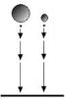

Acceleration Due to Gravity:

Acceleration of an object is the object’s change in velocity divided by the amount of time during which the change occurs. All objects accelerate toward the earth at a rate of 9.8m/s/s, or 9.8m/s2.

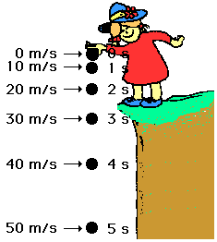

Velocity of Falling Objects:

To calculate the rate of a falling object, use the following equation:

Δv= g x t

Δv = change in velocity

t = time (s)

g = acceleration due to gravity on Earth = 9.8 m/s

s

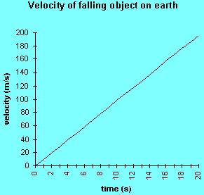

Refer to resource pages for math skills problems for calculating the velocity of falling objects.

Air Resistance and Falling Objects:

Air resistance is the force that opposes the motion of objects through air. The

amount of air resistance acting on an object depends on the size, shape, and

speed of the objects. For example, air resistance affects a flat sheet of paper more

than a crumpled one. The larger surface area of the flat sheet causes it to fall

at a slower rate than the crumpled sheet of paper.

 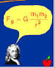

Consider an apple as it falls to the ground. The **force of gravity** is pulling down on the apple. If gravity were the only force acting on the apple, it would accelerate at a rate of 9.8m/s2. The **force of air resistance** is pushing up on the apple. This force is subtracted from the force of gravity to yield the net force. The **net force** on the apple is the force of air resistance subtracted from the force of gravity. Because the net force is not zero N, the apple accelerates downward, but the apple does not accelerate as fast as it would without air resistance.

Acceleration Stops at Terminal Velocity:

As the speed of a falling object increases, air resistance increases.

The upward force of air resistance continues to increase until it is equal to the downward

force of gravity, at which point, the net force is zero N and the object stops accelerating. The object then falls at a constant velocity which is referred to as terminal velocity.

There are advantages to terminal velocity. For example, a parachute increases the air

resistance of a sky diver and slows him down to a safe terminal velocity.

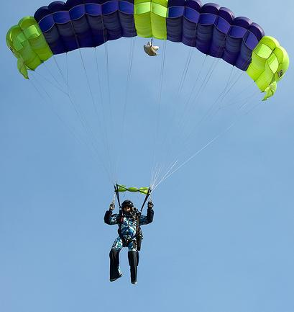

Free Fall Occurs When There is No Air Resistance:

An object is in free fall only if gravity is pulling the object down and

no other forces are acting on it. Because air resistance is a force, free fall can occur only where this is no air. Two places where this condition exists are in space and in a vacuum.

Discuss the example of feather and ball dropped at the same time in a vacuum.

Orbiting Objects in Free Fall:

Two Motions Combine to Cause Orbiting:

When a spacecraft orbits Earth, it is moving forward, but the spacecraft is

also in free fall toward Earth. The combination of these two motions

causes the spacecraft to orbit Earth.

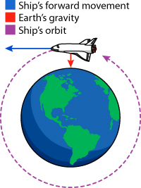

Orbiting and Centripetal Force:

Many objects in the universe are in orbit. For example, the moon orbits Earth, and Earth and other planets orbit the sun. These objects are traveling in a circular motion path. An object in circular motion is constantly changing direction, so because an unbalanced force is necessary to change the motion of any object, there must be an unbalanced force acting on any object traveling in circular motion.

The unbalanced force that causes objects to move in a circular path is called **centripetal force**, which means “toward the center.” Gravity provides the centripetal force that keeps objects in orbit.



Projectile Motion and Gravity:

**Projectile motion** is the curved path an object follows when it is thrown or propelled near the

surface of the earth. Projectile motion has two components, including vertical motion and

horizontal motion. The two components are independent and they have no effect on each other,

so when the two motions are combined, they form a curved path. For example, projectile motion

occurs when a pitcher throws a baseball. After the baseball leaves the pitcher’s hand, the ball’s

horizontal velocity is constant. The ball’s velocity increases because gravity causes it to

accelerate downward. The vertical motion and the horizontal motion combine to form

a curved path.

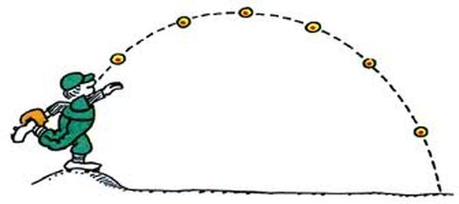

Allow students to brainstorm other examples of projectile motion. Some examples may include a frog leaping into a pond, a baseball being thrown, an arrow shot by an archer, balls being juggled, diving into a pool of water, etc.

Refer to student resource folder for student intended study guide.

Discussion Questions

1. Why do you have to aim above a target that you want to hit with a thrown object?

The thrown object will be in projectile motion and will therefore accelerate downward toward the Earth.

1. When does an object reach its terminal velocity? An object reaches its terminal velocity when the upward force of air resistance equals the downward force of gravity.
2. How does air resistance affect the acceleration of falling objects?

Air resistance reduces the acceleration of falling objects and causes them to fall more slowly.

1. How does gravity affect the two components of projectile motion? Gravity has not affect on the horizontal component of projectile motion. Gravity changes the vertical component of projectile motion by accelerating an object downward.
2. How is the acceleration of falling objects affected by gravity? The acceleration due to gravity is the same for all objects. (Note: This is true only near the surface of Earth and in when no air resistance acts on the objects) Also acceptable: The force of gravity causes the acceleration of falling objects.
3. Why is the acceleration due to gravity the same for all objects? A heavier object experiences a greater gravitational force than a lighter object does. But a heavier object is also harder to accelerate because it has more mass. The greater gravitational force is exactly balanced by the greater mass. So, all objects fall with the same acceleration.

Summary:

* Gravity causes all objects to accelerate toward Earth at a rate of 9.8 m/s2.
* Air resistance slows the acceleration of falling objects. An object falls at its terminal velocity when the upward force of air resistance equals the downward force of gravity.
* An object is in free fall if gravity is the only force acting on it.,
* Objects in orbit appear to be weightless because they are in free fall.
* A centripetal force is needed to keep objects in circular motion. Gravity acts as a centripetal force to keep objects in orbit.
* Projectile motion has two components-horizontal motional and vertical motion. Gravity affects only the vertical motion of projectile motion.

Math Skills Practice

*A rock at rest falls off a tall cliff and hits the valley below after 3.5 seconds.*

*What is the rock’s velocity as it hits the ground?*

Δv= g x t 9.8 m/s2 x 3.5 s = 34.3 m/s

Newton’s Laws of Motion:

This unit introduces students to Newton’s laws of motion. Before teaching this section,

the teacher may wish to review the concepts of acceleration, force, net force, friction, and

balanced and unbalanced forces with students.

Also, students could research Sir Isaac Newton (1686) and investigate Newton’s explanation

of the relationship between force and the motion of an object.

Teacher may refer to Resource Background Information about Sir Isaac Newton found in the

teacher resource folder.

Objectives:

* Describe Newton’s first law of motion, and explain how it relates to objects at rest

and objects in motion.

* State Newton’s second law of motion, and explain the relationship between force,

mass, and acceleration.

* State Newton’s third law of motion, and give example of force pairs.

Define vocabulary terms:

**Inertia**-The tendency of an object to resist being moved or, if the object is

moving, to resist a change in speed or direction until an outside force acts

on the object.

Refer to Teacher Resource Folder for PowerPoint Presentation

Refer to Student Resource Pages for study guide of Newton’s Laws of Motion

Have students make a Venn diagram that contains information about Newton’s Laws of Motion.

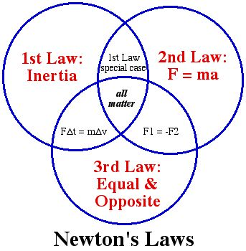

Newton’s First Law of Motion

|  |
| --- |
| **An object at rest will remain at rest unless acted on by an unbalanced force. An object in motion continues in motion with the same speed and in the same direction unless acted upon by an unbalanced force.**  **This law is often called "The Law of Inertia”** |

**Newton’s First Law of Motion is the reason you should always wear your seatbelt.**



+++++++++++++++++++++++++++++++++++++++++++++++++++++++++++++++++++++++++++++++

Newton’s Second Law of Motion

|  |
| --- |
| Acceleration is produced when a force acts on a mass. The greater the mass (of the object being accelerated) the greater the amount of force needed (to accelerate the object).FORCE = MASS times ACCELERATIONF = M x A |

 

Reinforcement activity: Students may conduct the Hot Wheels Lab found in Resource Folder

Newton’s Third Law of Motion

|  |
| --- |
| For every action there is an equal and opposite reaction. |

**Newton's Third Law.**

|  |
| --- |
| http://teachertech.rice.edu/Participants/louviere/Newton/rocket1.gif |
| **The rocket's action is to push down on the ground with the force of its powerful engines, and the reaction is that the ground pushes the rocket upwards with an equal force.** |

Reinforcement activity: Students may conduct the Balloon Racer Lab found in Resource Folder

Consider having each student memorize and recite each of Newton’s three laws of motion.

Discussion Questions

1. What does Newton’s first law of motion say about objects at rest and objects in motion?

Newton’s first law states that objects at rest tend to stay at rest and objects in motion tend

to stay in motion unless acted on by an unbalanced force.

1. How does Newton’s second law explain why it is easier to push a bicycle than to push a car

with the same acceleration? The bicycle has a smaller mass, so a smaller force is required

to give it the same acceleration as the car.

1. Use Newton’s second law to describe the relationship between force, mass, and acceleration. Newton’s second law states the acceleration of an object increases as the force acting on it increases, but the acceleration decreases as the mass of the object increase.
2. Use Newton’s third law to explain how a rocket accelerates. The hot gases expelled from the back

of the rocket produce a reaction force on the rocket that accelerates it upward.

1. List three examples of force pairs that occur when you do your homework. Accept all possible answers. Student should give examples using force pairs such as using a pencil: Action: Pencil pushing on paper Reaction: Paper pushing on pencil.

Summary:

* Newton’s first law of motion states that the motion of an object will not change unless an unbalanced force acts on it.
* Objects at rest will not move unless acted upon by an unbalanced force.
* Objects in motion will continue to move at a constant speed and in a straight line unless acted upon by an unbalanced force.
* Inertia is the tendency of matter to resist a change in motion. Mass is a measure of inertia.
* Newton’s second law of motion states that the acceleration of an object depends on its mass and on the force exerted on it.
* Newton’s second law is represented by the following equation: F=m x a.
* Newton’s third law of motion states that whenever on object exerts a force on a second object, the second object exerts an equal and opposite force on the first object.

Math Skills Practice

*What force is necessary to accelerate a 70 kg object at a rate o 4.2 m/s2?*

*F = mass x acceleration F=70 kg x 4.2 m/s2 = 294 N*

Momentum:

Objectives:

Calculate the momentum of moving objects.

Explain the law of conservation of momentum.

Define vocabulary terms:

**Momentum**- A quantity defined as the product of the mass and velocity

of an object.

Momentum, Mass, and Velocity

The **momentum** of an object depends on the object’s mass and velocity. The more momentum an object has, the harder it is to stop the object or to change its direction.

Calculating Momentum

Momentum (p) can be calculated using the equation below:

P = mass x velocity

In the equation above, *m* is the mass of an object in kilograms and *v* is the object’s velocity in meters per second. The units for momentum are kilograms multiplied by meters per second, or kg **·** m/s. Momentum has a direction, and its direction is always the same as the direction of the object’s velocity.

The Law of Conservation of Momentum

When a moving object hits another object, some or all of the momentum of the first object is transferred to the object that is hit. If only some of the momentum is transferred, the rest of the momentum stays with the first object. For example, imagine that a cue ball hits a billiard ball so the billiard ball starts moving and the cue ball stops. This example shows the *law of conservation of momentum,* which states that any time objects collide, the total amount of momentum stays the same.

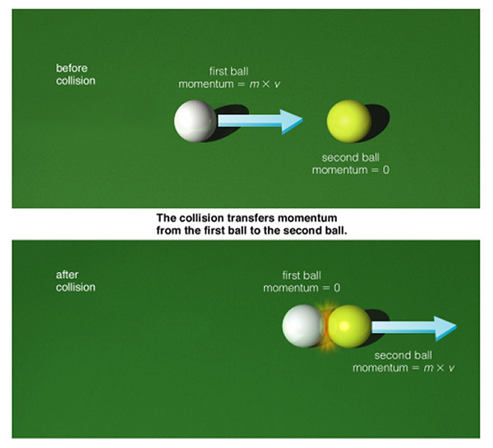

Conservation of Momentum and Newton’s Third Law of Motion

Newton’s third law of motion can be use to explain conservation of momentum. The example of the cue ball and the billiard discussed above can again be used to explain this relationship. When the cue ball hits the billiard ball with a certain amount of force, this force is the action force. The reaction force was the equal but opposite force exerted by the billiard ball on the cure ball. The action force made the billiard ball start moving, and the reaction force made the cue ball stop moving. Because the action and reaction forces are equal and opposite, momentum is neither gained nor lost.

Discussion Questions:

1. What is the equation for momentum? p = m x v
2. Explain the law of conservation of momentum. The law of conservation of momentum states that any time objects collide, the total amount of momentum stays the same. The law of conservation of momentum is true when no other forces act on the objects.
3. How is Newton’s third law of motion related to the law of conservation of momentum? Newton’s third law of motion can explain the law of conservation of momentum. Because the action and reaction forces are equal and opposite, momentum is neither gained nor lost.
4. Give an example of an object with a small mass that has a large momentum.

Explain your answer. Answers may vary. Example: A fastball pitched by a baseball pitcher has a small mass, but a large velocity, therefore, the ball has a large momentum.

Summary:

* Momentum is a property of moving objects.
* Momentum is calculated by multiplying the mass of an object by the object’s velocity.
* When two or more objects collide, momentum may be transferred, but the total amount

of momentum does not change. This is the law of conservation of momentum.

Math Skills Practice:

*Calculate the momentum of a 2.5 kg puppy that is running with a velocity of 4.8 m/s south.*

P = mass x velocity p = 2.5 kg x 4.8 m/s south = 12 kg **·** m/s south

Modified - Reference Holt, Rinehart and Winston (2005) INSB 0-03-043217-0