Background Information

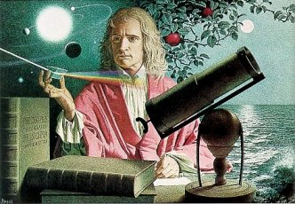
Sir Isaac Newton was one of the greatest scientists and mathematicians that ever lived. He was born in England on December 25, 1643, the same year that Galileo died.

Sir Isaac Newton was raised by his grandmother. Newton attended Free Grammar School and then went on to Trinity College Cambridge, where he worked his way through college. While at college he became interested in math, physics, and astronomy. Newton received both a bachelors and masters degree.

While Newton was in college he was writing his ideas in a journal. Newton had new ideas about motion, which he called his three laws of motion. He also had ideas about gravity, the diffraction of light, and forces. Newton's ideas were so good that Queen Anne knighted him as Sir Isaac Newton in 1705. His accomplishments laid the foundations for modern science and revolutionized the world. Sir Isaac Newton died in 1727 at the age of 85.

Modified - Reference - http://teachertech.rice.edu/Participants/louviere/Newton/newton.html

